
p
APPLICATION
DEVELOPMENT PRACTICE 4
Data Structures Algorithms
July Assignment

Group Members:

No. | Surname and Name | Student Number
1 | Kabai Moipone | 2 | 1 | 5 | 2 | 0 | 3 | 5 | 6 | 9
2 | Msomi Sebe | 2 | 1 | 6 | 0 | 2 | 8 | 6 | 0 | 4

Due Date: 27 July 2020
Problem 1: Implement two stacks in one array called Arr of size n in such a way that neither stack overflows unless the total number of elements in both stacks together is n.
package org.example.listpackage;
/*
* Sebe Msomi 216028604
* Moipone Kabai 215203569
* */
public class StackClass {
private String[] arr;
private int size;
private int top1, top2;
// Constructor
public StackClass(int n)
{
size = n;
arr = new String[n];
top1 = -1;
top2 = n;
}
// Function to insert a given element into the first stack
public void push1(String key)
{
// check if the array is full
if (top1 + 1 >= top2)
{
System.out.println("Stack Overflow");
System.exit(-1);
}
top1++;
arr[top1] = key;
}
// Function to insert a given element into the second stack
public void push2(String key)
{
// check if the array is full
if (top1 + 1 == top2)
{
System.out.println("Stack Overflow");
System.exit(-1);
}
top2--;
arr[top2] = key;
}

// pop an element from the first stack
public String pop1()
{
// if no elements in the array
if (top1 < 0)
{
System.out.println("Stack UnderFlow");
System.exit(-1);
}
String top = arr[top1];
top1--;
return top;
}
// pop an element from the second stack
public String pop2()
{
// if no elements in the array
if (top2 >= size)
{
System.out.println("Stack UnderFlow");
System.exit(-1);
}
String top = arr[top2];
top2++;
return top;
}
}

Main Class
package org.example.listpackage;
/*
* Sebe Msomi 216028604
* Moipone Kabai 215203569
* */
import java.util.Arrays;
import java.util.List;
public class StackMainClass {
public static void main(String[] args) {
List<String> list1 = Arrays.asList("jan", "feb", "mar", "apr", "may");
List<String> list2 = Arrays.asList("jun", "jul", "aug", "sep", "oct");
StackClass stack = new StackClass(list1.size() + list2.size());
for (String k : list1) {
stack.push1(k);
System.out.println("stack : " + k);
}
System.out.println(" stack : " + stack.pop1());
for (String j : list2) {
stack.push2(j);
// System.out.println("stack : " + j);
}
System.out.println(" stack on push2 method : " + stack.pop2());
}
}

Test case for problem 1
package org.example;
import org.example.listpackage.StackClass;
import org.junit.Test;
import java.util.Arrays;
import java.util.List;
import static org.hamcrest.core.Is.is;
import static org.junit.Assert.assertThat;
public class StackClassTest {
@Test
public void stackTest() throws Exception {
List<String> list1 = Arrays.asList("jan", "feb", "mar", "apr", "may");
List<String> list2 = Arrays.asList("jun", "jul", "aug", "sep", "oct");
StackClass stack = new StackClass(list1.size() + list2.size());
stack.push1("jan");
stack.push1("feb");
stack.push2("mar");
stack.push2("apr");
assertThat(stack.pop1(), is("feb"));
assertThat(stack.pop2(), is("apr"));
}
}

Input for problem 1
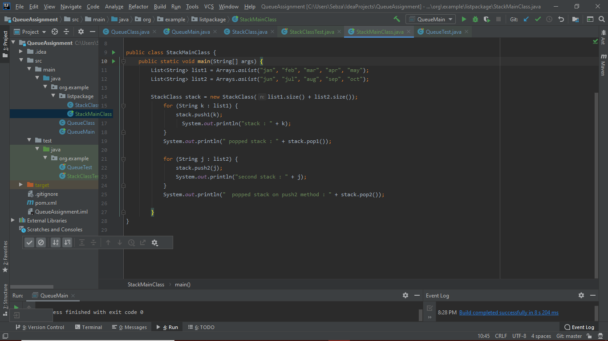
Input for problem 1
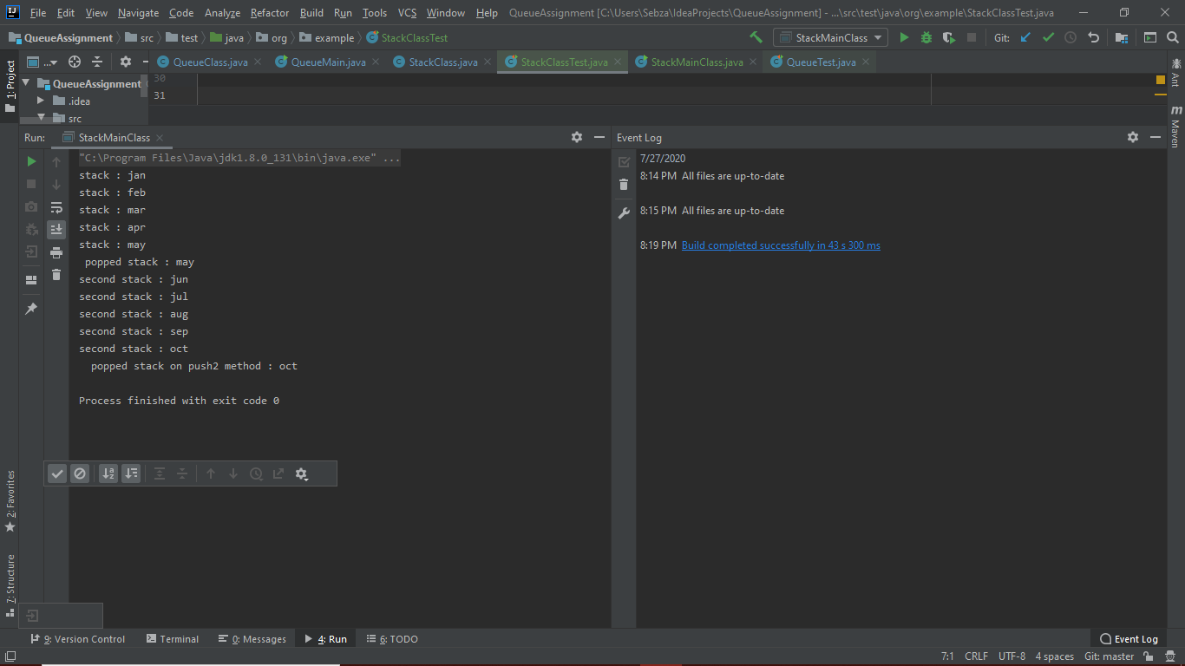
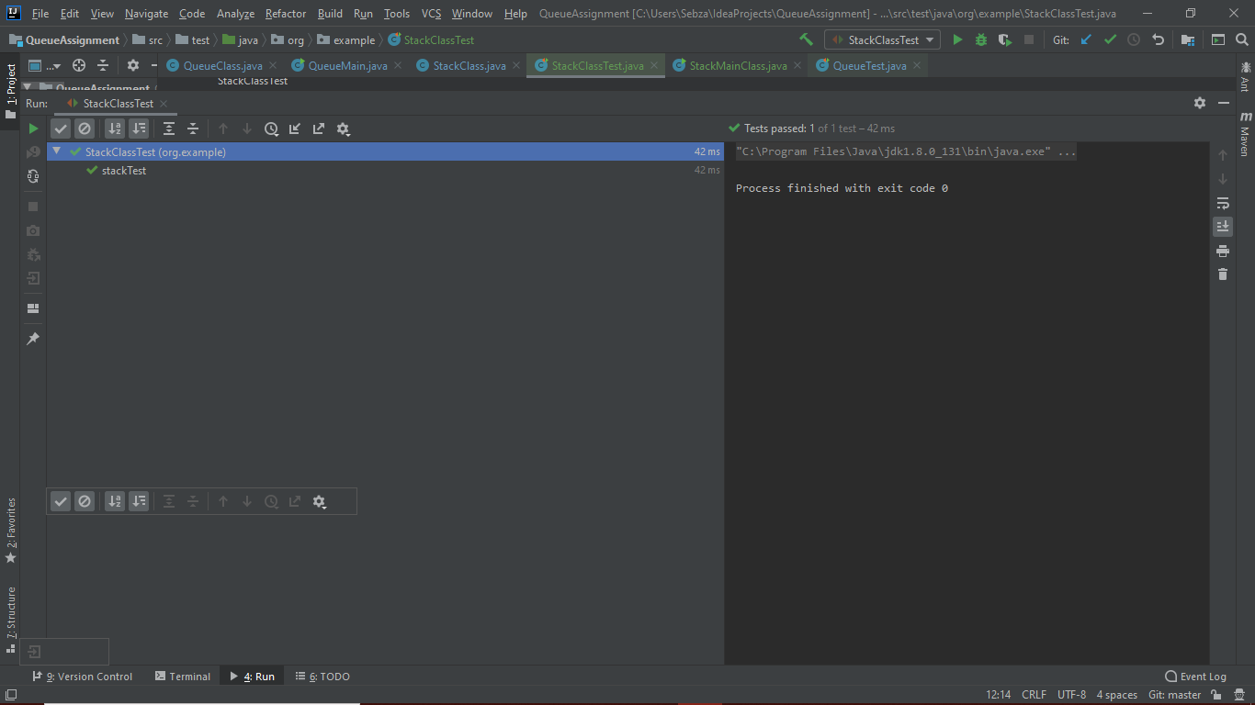
Problem 2: Show how to implement a queue using two stacks
ackage org.example;
import java.util.NoSuchElementException;
import java.util.Stack;
/*
* Sebe Msomi 216028604
* Moipone Kabai 215203569
* */
public class QueueClass {
Stack<String> stack1 = new Stack();
Stack<String> stack2 = new Stack();
public void enqueue(String e)
{
stack1.push(e);//pushing elements to
System.out.println(stack1);
}
public String dequeue()
{
//checking if both stacks are empty
if(stack1.isEmpty() && stack2.isEmpty()) throw new NoSuchElementException("The stack is empty");

//pushing stack if stack1 is not empty and stack2 is
if(stack2.isEmpty()){
while(!stack1.isEmpty())
{
stack2.push(stack1.pop());
System.out.println(stack2);
}
}
return stack2.pop();
}
public String front()
{
if(stack2.isEmpty()){
while(!stack1.isEmpty())
{
stack2.push(stack1.pop());
System.out.println(stack2);
}
}
return stack2.peek();
}

public Boolean isEmpty(){
return stack1.isEmpty() && stack2.isEmpty();//return true if the stacks are empty
}
public int size(){
return stack1.size() + stack2.size();
}
}

Main Class
package org.example;
import java.util.Stack;
/*
* Sebe Msomi 216028604
* Moipone Kabai 215203569
* */
public class QueueMain {
public static void main( String[] args )
{
QueueClass list = new QueueClass();
list.enqueue("Red");
list.enqueue("Green");
list.enqueue("Blue");
list.dequeue();
list.enqueue("Yellow");
list.enqueue("Pink");
list.enqueue("maroon");
list.dequeue();
list.isEmpty();
list.size();
list.front();
for(int i = 0; i<list.size(); i++){
System.out.println("The list is: " + list.size() + " " +list.isEmpty()+ " "+
list.dequeue());
}
}
}

Test case for problem 2
package org.example;
import org.junit.Test;
import static org.hamcrest.core.Is.is;
import static org.junit.Assert.assertThat;
/*
* Sebe Msomi 216028604
* Moipone Kabai 215203569
* */
public class QueueTest {
@Test
public void enqueueTest() throws Exception {
QueueClass queue = new QueueClass();
queue.enqueue("Red");
queue.enqueue("Green");
queue.enqueue("Blue");
assertThat(queue.dequeue(), is("Red"));
assertThat(queue.dequeue(), is("Green"));
}
}

Input for problem 2
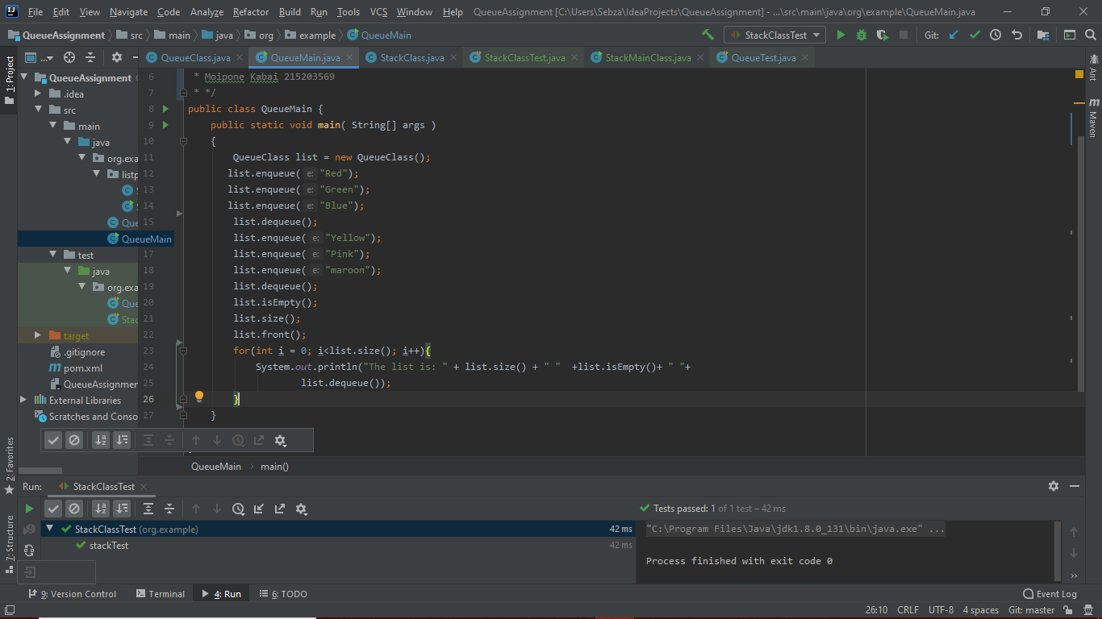
Output for problem 2
